**Issue 3**: CVV field is missing in the payment screen

**Description**: The credit/debit cards contain CVV number which authenticates the payment. However, in the below form, CVV field is not present anywhere near the card details area.

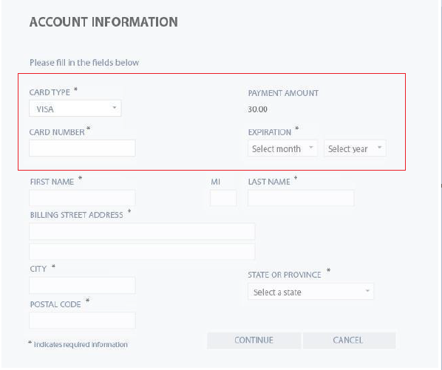

**Expected Behavior**: A field to enter user’s CVV should be present

**Severity**: Critical